**ABSTRACT**

Oil Pipeline Inspection Surveillance Robot

In this project the robotic is designed to move inside the oil pipeline to monitor

1. Any objects/obstacles which is present inside the pipe,
2. The current temperature value in degree Celsius,
3. The current humidity value in percentage,
4. Light /darkness inside the pipe
5. Real time Video out

This robot is controlled by android mobile phone and the wireless Bluetooth communication technology is used to control the robotic movements inside the pipelines.

The camera is interfaced with the robotic to capture the video inside the pipelines and the captured video is viewed through the monitor which is present in the base station.

The temperature sensor sense the current temperature reading and convert to degree Celsius and displays on mobile phone.

The Humidity sensor sense the current humidity reading and convert to percentage and displays on mobile phone.

The obstacle sensor detect the obstacle inside the pipe using ultrasound technology and send the message “obstacle detected” to mobile phone.

The camera capture the images in the presents of light, the light detector sensor detect the light intensity present inside the oil pipe , if there is low light intensity automatically turn on the camera light, other ways turns off.

Block diagram

Oil Pipeline Inspection Surveillance Robot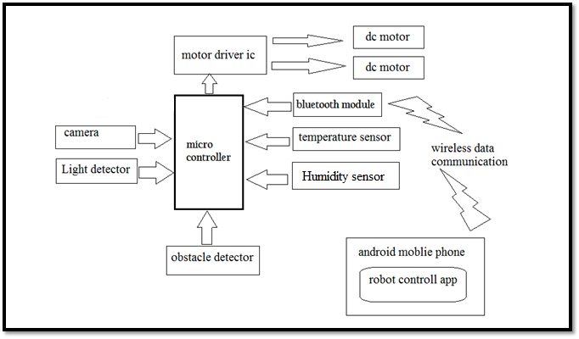

How an android phone control the robot?

The Android application controlled robot communicates via Bluetooth to the Bluetooth module present on the robot.

While pressing each button on the application, corresponding commands are sent via Bluetooth to the robot. The commands that are sent are in the form of ASCII. The microcontroller on the robot then checks the command received with its previously defined commands and controls the motors depending on the command received to cause it to move forward, backward, left, right or to stop.

It also displays the sensor values / physical readings in the android application

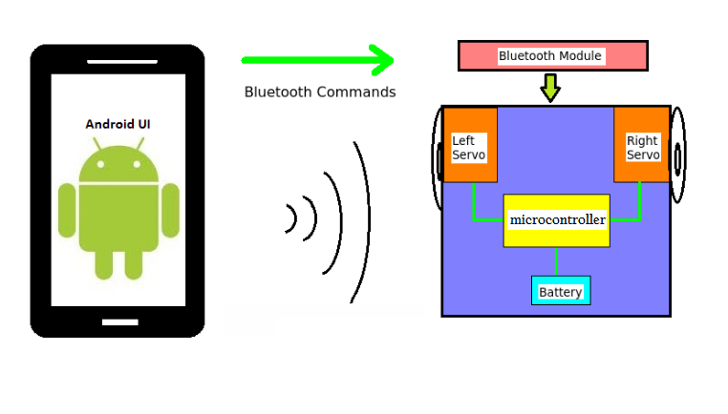

**INTRODUCTION**

Industries that operate pipeline networks (water, gas, oil and its derivatives, or any other fluid) spend large sums of money on early Failure detection every year. This interest in early detection is usually derived from the large cost that a severe break can generate as compared to the relatively inexpensive reparation of early-detected failures.

Pipelines which are tools for transporting oils, gases, and other fluids, such as chemicals, have been employed as major utilities in a number of countries for long time. Recently, many troubles have occurred in pipelines, and most of them are caused by aging, corrosion, cracks, and mechanical damages from third parties.

Even though lasting activities for maintenance are strongly demanded, they need enormous budgets that may not be easily handled by related industries. Currently, the applications of robots for the maintenance of the pipeline utilities are considered as one of the most attractive solutions available.

**Components used**

* ATMEGA328P MICROCONTROLLER
* Gear Motors 100rpm
* Bluetooth module HC-05
* Motor Driver ic L293D
* 9 Volt Rechargeable Battery
* Battery Connector
* Robot chaises
* DHT11 Temperature & Humidity sensor
* LED
* LDR
* Resisters and capacitors
* 7805 voltage regulator
* Ultrasonic sensor